**REACT**

**Exercise 1 :**

Create a new React Application with the name “myfirstreact”, Run the application to print “welcome to the first session of React” as heading of that page.

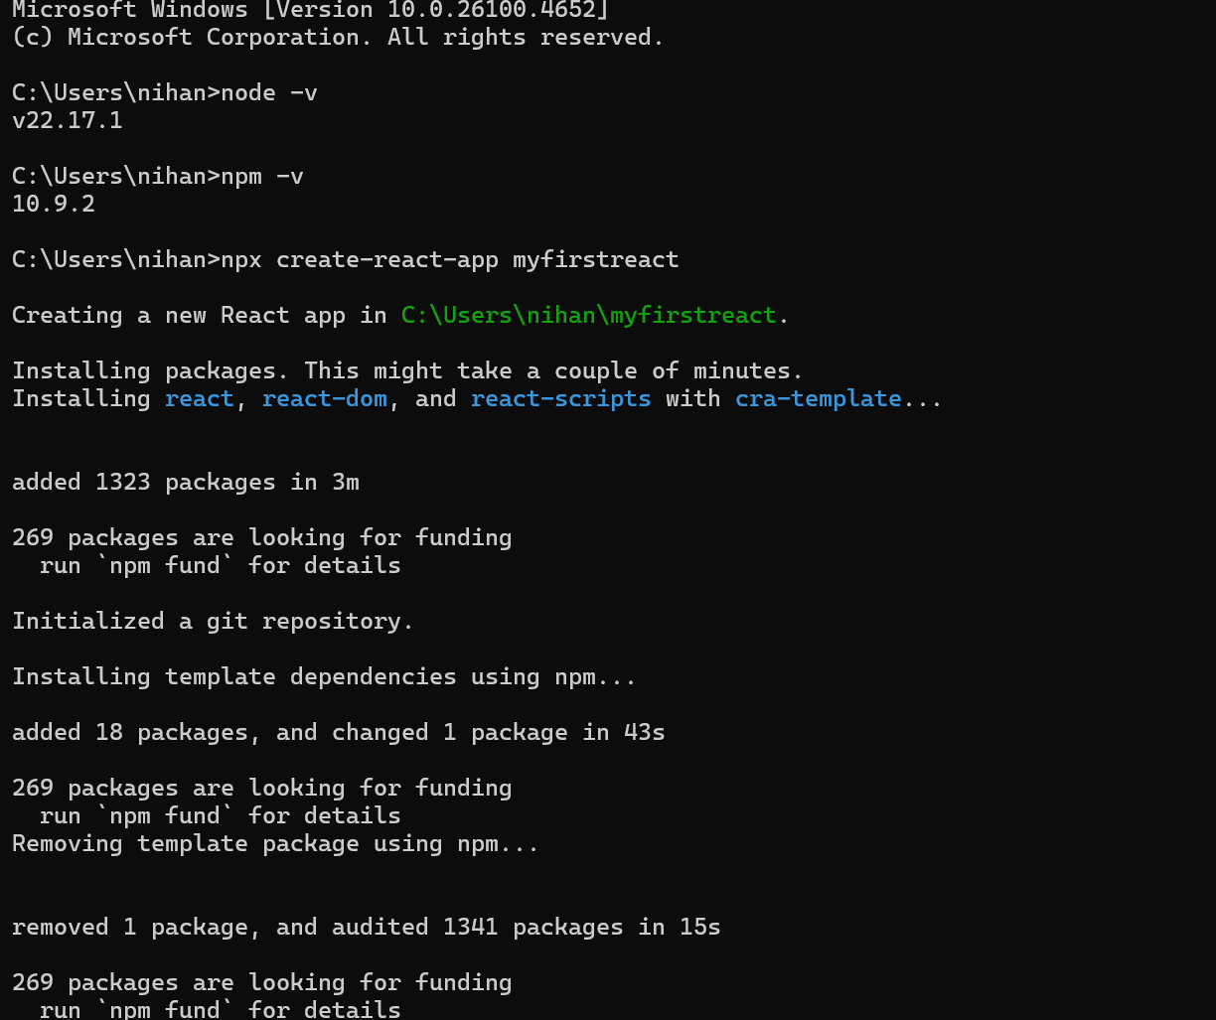

[**App.js**](http://app.js) **:**

import React from 'react';

function App() {

return (

<div>

<h1>welcome to the first session of React</h1>

</div>

);

}

export default App;

**Output :**

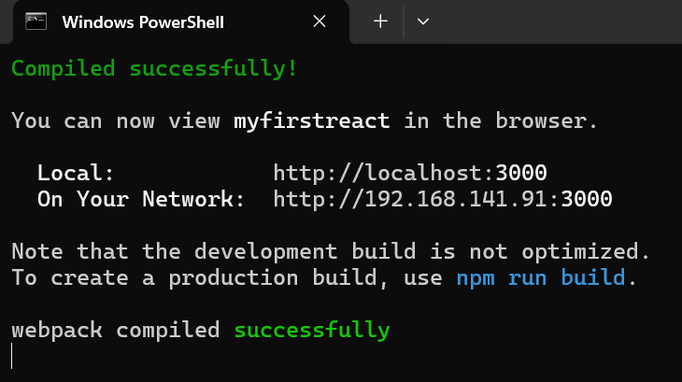

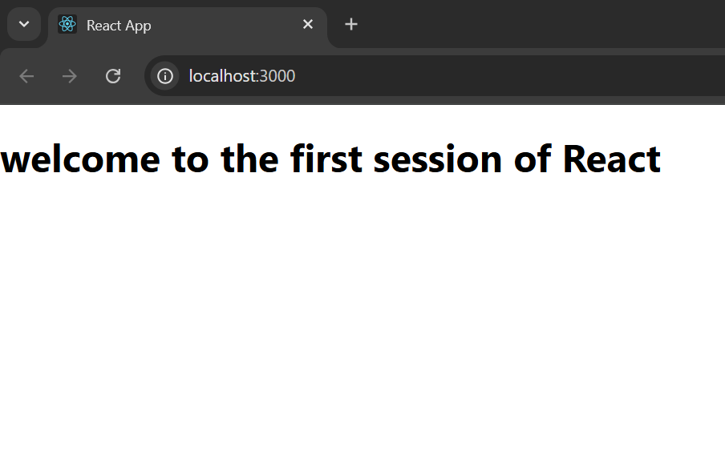

**Exercise 2 :**

Create a react app for Student Management Portal named StudentApp and create a component named Home which will display the Message “Welcome to the Home page of Student Management Portal”. Create another component named About and display the Message “Welcome to the About page of the Student Management Portal”. Create a third component named Contact and display the Message “Welcome to the Contact page of the Student Management Portal”. Call all the three components.

[**Home.js**](http://home.js) **:**

import React from 'react';

function Home() {

return (

<div>

<h2>Welcome to the Home page of Student Management Portal</h2>

</div>

);

}

export default Home;

[**About.js**](http://about.js) **:**

import React from 'react';

function About() {

return (

<div>

<h2>Welcome to the About page of the Student Management Portal</h2>

</div>

);

}

export default About;

[**Contact.js**](http://contact.js) **:**

import React from 'react';

function Contact() {

return (

<div>

<h2>Welcome to the Contact page of the Student Management Portal</h2>

</div>

);

}

export default Contact;

[**App.js**](http://app.js) **:**

import React from 'react';

import Home from './Components/Home';

import About from './Components/About';

import Contact from './Components/Contact';

function App() {

return (

<div>

<Home />

<About />

<Contact />

</div>

);

}

export default App;

**Output :**

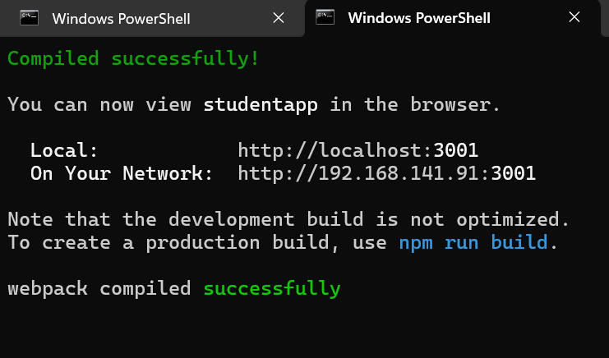

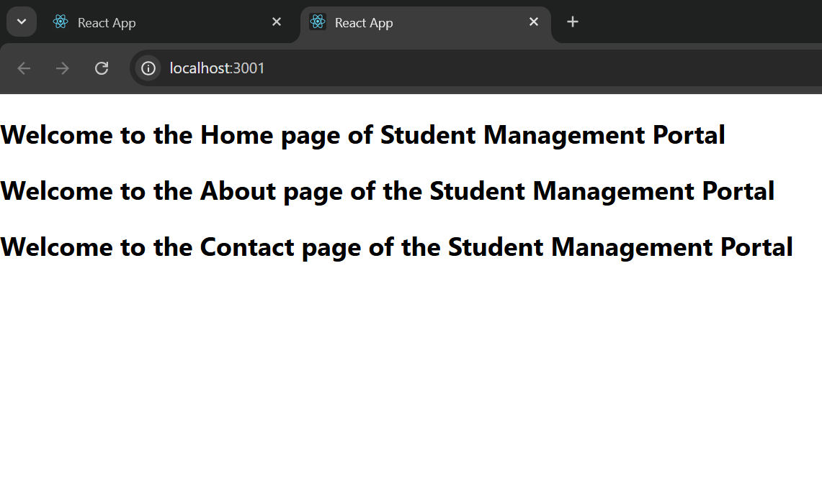

**Exercise 3**

Create a react app for Student Management Portal named scorecalculatorapp and create a function component named “CalculateScore” which will accept Name, School, Total and goal in order to calculate the average score of a student and display the same.

[**CalculateScore.js**](http://calculatescore.js) **:**

import React from 'react';

import '../Stylesheets/mystyle.css';

function CalculateScore(props) {

const average = props.total / props.goal;

return (

<div className="score-container">

<h2>Student Score Details</h2>

<p><strong>Name:</strong> {props.name}</p>

<p><strong>School:</strong> {props.school}</p>

<p><strong>Total Marks:</strong> {props.total}</p>

<p><strong>Goal:</strong> {props.goal}</p>

<p className="highlight"><strong>Average Score:</strong> {average.toFixed(2)}</p>

</div>

);

}

export default CalculateScore;

**mystyle.css :**

.score-container {

border: 2px solid #007bff;

padding: 20px;

margin: 20px auto;

max-width: 500px;

border-radius: 10px;

background-color: #f0f8ff;

box-shadow: 2px 2px 10px rgba(0,0,0,0.1);

}

.score-container h2 {

color: #007bff;

text-align: center;

}

.score-container p {

font-size: 18px;

margin: 8px 0;

}

.highlight {

font-weight: bold;

color: green;

}

[**App.js**](http://app.js) **:**

import React from 'react';

import CalculateScore from './Components/CalculateScore';

function App() {

return (

<div className="App">

<CalculateScore

name="John Doe"

school="Green Valley High School"

total={450}

goal={5}

/>

</div>

);

}

export default App;

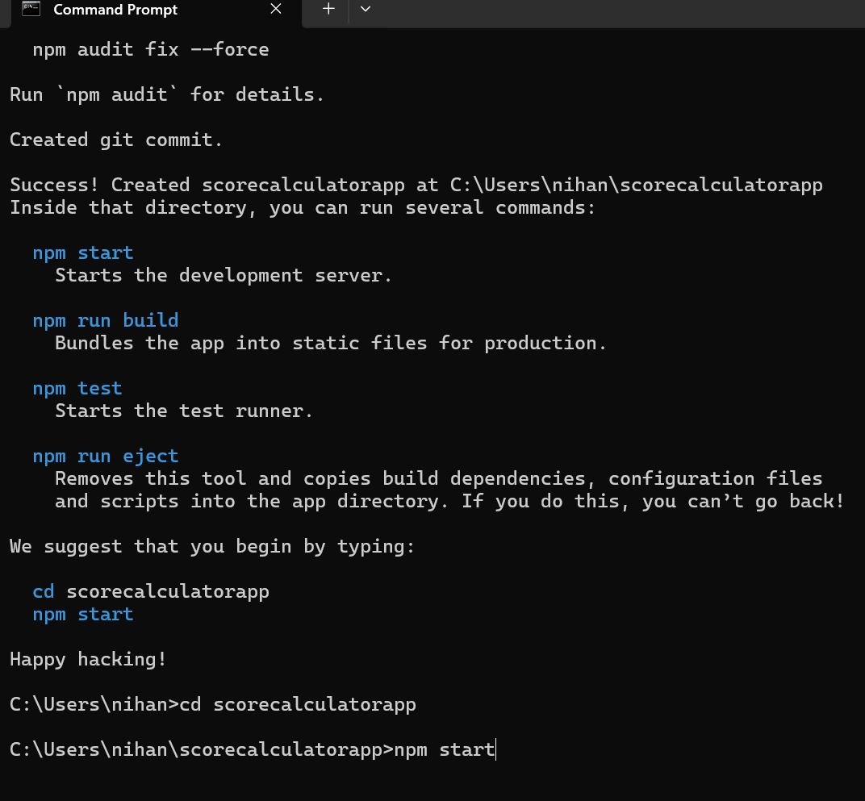

**Output :**

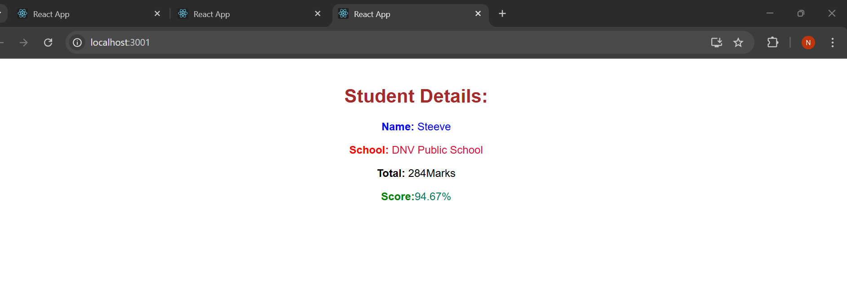

**Exercise 4 :**

Create a new react application using *create-react-app* tool with the name as “blogapp”

[**Posts.js**](http://posts.js) **:**

import React from 'react';

class Posts extends React.Component {

constructor(props) {

super(props);

this.state = {

posts: [],

hasError: false,

errorInfo: null

};

}

loadPosts() {

const englishPosts = [

{

id: 1,

title: 'Understanding React Lifecycle Methods',

body: 'React lifecycle methods allow developers to hook into different phases of a component’s life, such as mounting, updating, and unmounting.'

},

{

id: 2,

title: 'What is componentDidMount?',

body: 'componentDidMount is called once the component is inserted into the DOM. It is often used to fetch data from an API.'

},

{

id: 3,

title: 'Using componentDidCatch for Error Handling',

body: 'componentDidCatch helps in catching JavaScript errors in the UI components and logs error details for better debugging.'

},

{

id: 4,

title: 'React Class vs Functional Components',

body: 'Class components offer more control through lifecycle methods, while functional components are simpler and support Hooks for state and side-effects.'

}

];

this.setState({ posts: englishPosts });

}

componentDidMount() {

this.loadPosts();

}

componentDidCatch(error, info) {

this.setState({ hasError: true, errorInfo: error.toString() });

alert("Rendering error: " + error.toString());

}

render() {

if (this.state.hasError) {

return <h2>Error occurred: {this.state.errorInfo}</h2>;

}

return (

<div style={{ padding: '20px', fontFamily: 'Arial' }}>

<h1>Blog Posts</h1>

{this.state.posts.map(post => (

<div

key={post.id}

style={{

padding: '15px',

margin: '15px 0',

borderBottom: '1px solid #ccc'

}}

>

<h3 style={{ fontWeight: 'bold' }}>{post.title}</h3>

<p>{post.body}</p>

</div>

))}

</div>

);

}

}

export default Posts;

[**post.js**](http://post.js) **:**

// src/Post.js

class Post {

constructor(userId, id, title, body) {

this.userId = userId;

this.id = id;

this.title = title;

this.body = body;

}

}

export default Post;

[**App.js**](http://app.js) **:**

import React from 'react';

import Posts from './Posts';

function App() {

return (

<div className="App">

<Posts />

</div>

);

}

export default App;

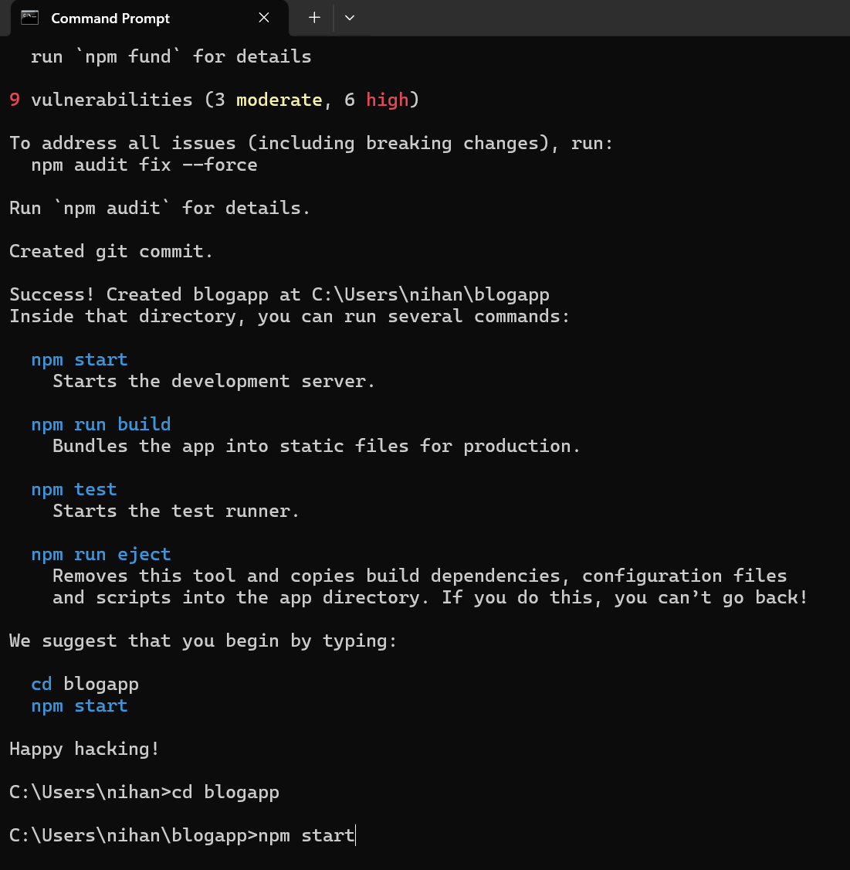

**Output :**

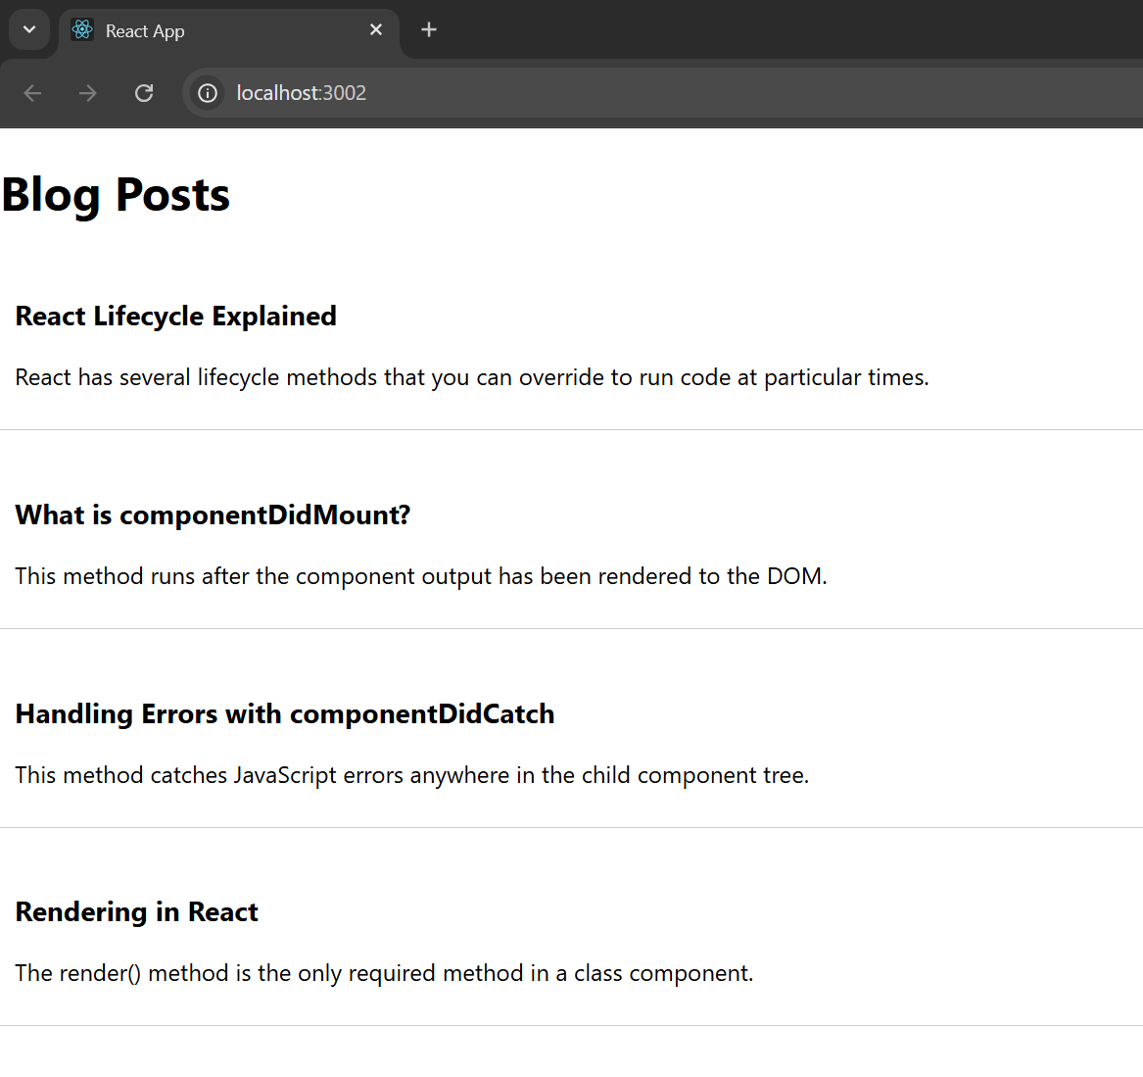

**Exercise 5 :**

My Academy team at Cognizant want to create a dashboard containing the details of ongoing and completed cohorts. A react application is created which displays the detail of the cohorts using react component. You are assigned the task of styling these react components.

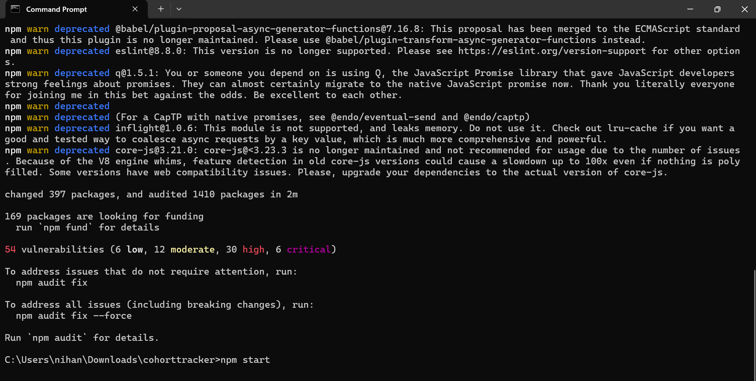

**CohortDetails.module.css :**

.box {

width: 300px;

display: inline-block;

margin: 10px;

padding: 10px 20px;

border: 1px solid black;

border-radius: 10px;

vertical-align: top;

}

dt {

font-weight: 500;

}

.heading {

font-size: 20px;

font-weight: bold;

margin-bottom: 10px;

}

[**CohortDetails.js**](http://cohortdetails.js) **:**

import React from 'react';

import styles from './CohortDetails.module.css';

function CohortDetails({ name, startedOn, status, coach, trainer }) {

const nameStyle = {

color: status.toLowerCase() === 'ongoing' ? 'green' : 'blue',

fontWeight: 'bold',

fontSize: '16px'

};

return (

<div className={styles.box}>

<div style={nameStyle}>{name}</div>

<dl>

<dt>Started On</dt>

<dd>{startedOn}</dd>

<dt>Current Status</dt>

<dd>{status}</dd>

<dt>Coach</dt>

<dd>{coach}</dd>

<dt>Trainer</dt>

<dd>{trainer}</dd>

</dl>

</div>

);

}

export default CohortDetails;

[**App.js**](http://app.js) **:**

import React from 'react';

import CohortDetails from './CohortDetails';

function App() {

return (

<div style={{ border: '1px solid black', padding: '20px' }}>

<h2 style={{ fontWeight: 'bold' }}>Cohorts Details</h2>

<CohortDetails

name="INTADMDF10 - .NET FSD"

startedOn="22-Feb-2022"

status="Scheduled"

coach="Aathma"

trainer="Jojo Jose"

/>

<CohortDetails

name="ADM21JF014 - Java FSD"

startedOn="10-Sep-2021"

status="Ongoing"

coach="Apoorv"

trainer="Elisa Smith"

/>

<CohortDetails

name="CDBJF21025 - Java FSD"

startedOn="24-Dec-2021"

status="Ongoing"

coach="Aathma"

trainer="John Doe"

/>

</div>

);

}

export default App;

**Output :**

